United Kingdom
Last updated on 2021-01-17

Epidemic situation overview
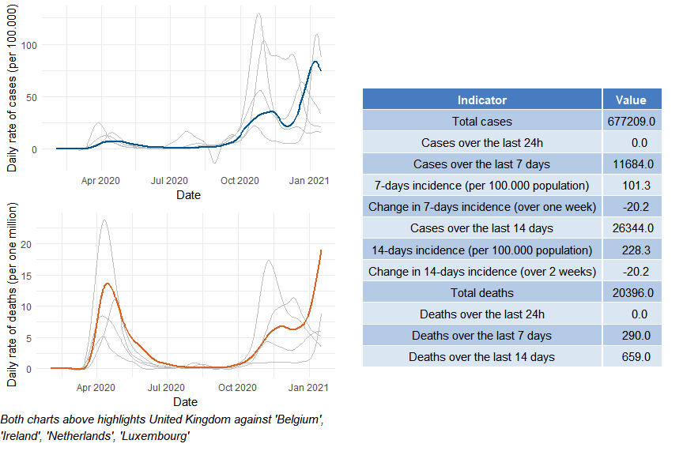

United Kingdom

Public health and social measures
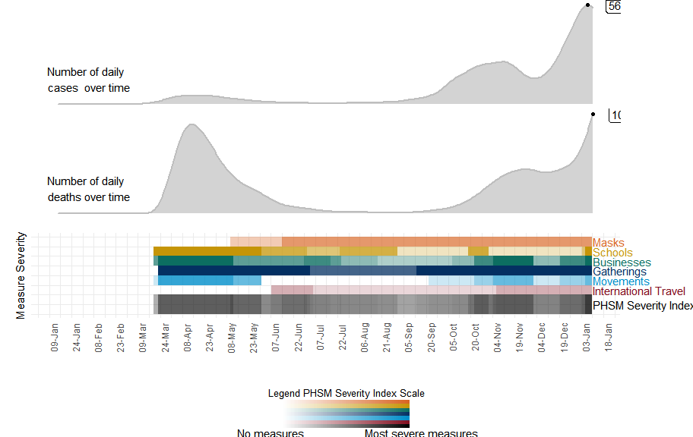

United Kingdom

Subnational analysis

United Kingdom

Vaccination overview

